朱毅德20104380153 | 等离子体物理学 | November 3, 2013

Tokamak Research Report

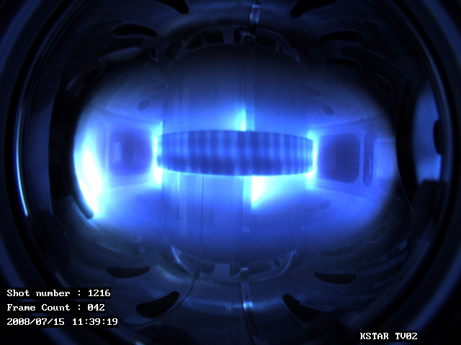

Contents

Generalization 2

Etymology 2

History 2

Toroidal design 3

Plasma heating 5

Tokamak cooling 6

Experimental tokamaks 6

Table: Fusion experimental devices by confinement method 7

ITER 8

Background 9

objectives 9

timetable 9

Reactor overview 10

Technical design 11

criticism 16

Bibliography 17

# Generalization[1]

A tokamak is a device using a magnetic field to confine a plasma in the shape of a torus. Achieving a stable plasma equilibrium requires magnetic field lines that move around the torus in a helical shape. Such a helical field can be generated by adding a toroidal field (traveling around the torus in circles) and a poloidal field (traveling in circles orthogonal to the toroidal field). In a tokamak, the toroidal field is produced by electromagnets that surround the torus, and the poloidal field is the result of a toroidal electric current that flows inside the plasma. This current is induced inside the plasma with a second set of electromagnets.

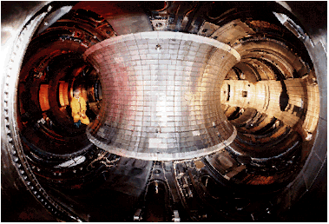The tokamak is one of several types of magnetic confinement devices, and is one of the most-researched candidates for producing controlled thermonuclear fusion power. Magnetic fields are used for confinement since no solid material could withstand the extremely high temperature of the plasma. An alternative to the tokamak is the stellarator.

Princeton Plasma Physics Laboratory Tokamak TFTR. http://ippex.pppl.gov/fusion/fusion4.htm

Tokamaks were invented in the 1950s by Soviet physicists Igor Tamm and Andrei Sakharov, inspired by an original idea of Oleg Lavrentiev.

## Etymology

The word tokamak is a transliteration of the Russian word токамак, an acronym of either “тороидальная камера с магнитными катушками”—toroidal chamber with magnetic coils, or “**то**роидальная **кам**ера с **ак**сиальным магнитным полем”—toroidal chamber with axial magnetic field.

## History

Although nuclear fusion research began soon after World War II, the programs in various countries were each initially classified as secret. It was not until after the 1955 United Nations International Conference on the Peaceful Uses of Atomic Energy in Geneva that programs were declassified and international scientific collaboration could take place.

Experimental research of tokamak systems starts in 1956 in Kurchatov Institute, Moscow by a group of Soviet scientists led by Lev Artsimovich. The group constructed the first tokamaks, the most successful being T-3 and its larger version T-4. T-69 was tested in 1968 in Novosibirsk, conducting the first ever quasi-stationary thermonuclear fusion reaction.

In 1968, at the third IAEA International Conference on Plasma Physics and Controlled Nuclear Fusion Research at Novosibirsk, Soviet scientists announced that they had achieved electron temperatures of over 1000 eV in a tokamak device. British and American scientists met this news with skepticism, since they were far from reaching that benchmark; they remained suspicious until laser scattering tests confirmed the findings next year.

## Toroidal design

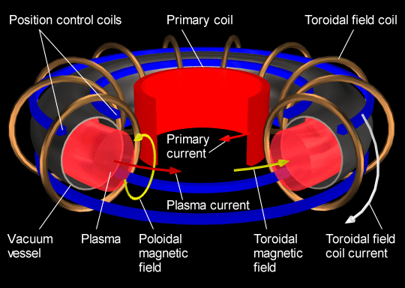

Main components of the tokamak type magnetic confinement system.

http://www.plasma.inpe.br/LAP_Portal/LAP_Site/Text/Tokamaks.htm

Positively and negatively charged ions and negatively charged electrons in a fusion plasma are at very high temperatures, and have correspondingly large velocities. In order to maintain the fusion process, particles from the hot plasma must be confined in the central region, or the plasma will rapidly cool. Magnetic confinement fusion devices exploit the fact that charged particles in a magnetic field experience a Lorentz force and follow helical paths along the field lines.

Early fusion research devices were variants on the Z-pinch (a type of plasma confinement system that uses an electrical current in the plasma to generate a magnetic field that compresses it) and used electrical current to generate a *poloidal* magnetic field to contain the plasma along a linear axis between two points. Researchers discovered that a simple toroidal field, in which the magnetic field lines run in circles around an axis of symmetry, confines a plasma hardly better than no field at all. This can be understood by looking at the orbits of individual particles. The particles not only spiral around the field lines, they also drift across the field. Since a toroidal field is curved and decreases in strength moving away from the axis of rotation, the ions and the electrons move parallel to the axis, but in opposite directions. The charge separation leads to an electric field and additional drift, in this case outward for both ions and electrons. Alternatively, the plasma can be viewed as a torus of fluid with a magnetic field frozen in. The plasma pressure results in a force that tends to expand the torus. The magnetic field outside the plasma cannot prevent this expansion. The plasma simply slips between the field lines.

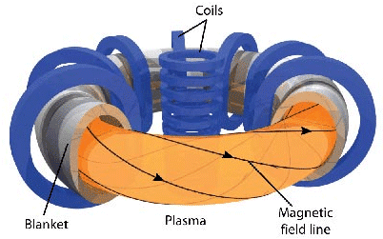For a toroidal plasma to be effectively confined by a magnetic field, there must be a twist to the field lines. There are then no longer flux tubes that simply encircle the axis, but, if there is sufficient symmetry in the twist, flux surfaces. Some of the plasma in a flux surface will be on the outside (larger major radius, or “low-field side”) of the torus and will drift to other flux surfaces father from the circular axis of the torus. Other portions of the plasma in the flux surface will be on the inside (smaller major radius, or “high-field side”). Since some of the outward drift is compensated by an inward drift on the same flux surface, there is a macroscopic equilibrium with much improved confinement. Another way to look at the effect of twisting the field lines is that the electric field between the top and the bottom of the torus, which tends to cause the outward drift, is shorted out because there are now field lines connecting the top to the bottom.

Tokamak: Future of Nuclear Power. http://new.math.uiuc.edu/math198/MA198-2009/farrell1/

When the problem is considered even more closely, the need for a vertical (parallel to the axis of rotation) component of the magnetic field arises. The Lorentz force of the toroidal plasma current in the vertical field provides the inward force that holds the plasma torus in equilibrium.

This device where a large toroidal current is established (15 Mega-amps in ITER) suffers from a fundamental problem of stability. The nonlinear evolution of magnetohydrodynamical instabilities leads to a dramatic quench of the plasma current on a very short time scale, of the order of the millisecond. Very energetic electrons are created (runaway electrons) and a global loss of confinement is finally obtained. A very high energy is deposited on small areas. This phenomenon is called a major disruption. The occurrence of major disruptions in running tokamaks has always been rather high, of the order of a few percent of the total numbers of the shots. In currently operated tokamaks, the damage is often large but rarely dramatic. In the ITER tokamak, it is expected that the occurrence of a limited number of major disruptions will definitively damage the chamber with no possibility to restore the device.

## Plasma heating

In an operating fusion reactor, part of the energy generated will serve to maintain the plasma temperature as fresh deuterium and tritium are introduced. However, in the startup of a reactor, either initially or after a temporary shutdown, the plasma will have to be heated to its operating temperature of greater than 10 keV (over 100 million degrees Celsius). In current tokamak (and other) magnetic fusion experiments, insufficient fusion is produced to maintain the plasma temperature.

1. Ohmic heating

Since the plasma is an electrical conductor, it is possible to heat the plasma by inducing a current through it; in fact, the induced current that heats the plasma usually provides most of the poloidal field. The current is induced by slowly increasing the current through an electromagnetic winding linked with the plasma torus: the plasma can be viewed as the secondary winding of a transformer. This is inherently a pulsed process because there is a limit to the current through the primary. Tokamaks must therefore either operate for short periods or rely on other means of heating and current drive. The heating caused by the induced current is called Ohmic (or resistive) heating; it is the same kind of heating that occurs in an electric light bulb or in an electric heater. The heat generated depends on the resistance of the plasma and the amount of electric current running through it. But as the temperature of heated plasma rises, the resistance decreases and ohmic heating becomes less effective. It appears that the maximum plasma temperature attainable by ohmic heating in a tokamak is 20-30 million degrees Celsius. To obtain still higher temperatures, additional heating methods must be used.

1. Neutral-beam injection

Neutral-beam injection involves the introduction of high-energy (rapidly moving) atoms into the ohmically heated, magnetically confined plasma. The atoms are ionized as they pass through the plasma and are trapped by the magnetic field. The high-energy ions then transfer part of their energy to the plasma particles in repeated collisions, increasing the plasma temperature.

1. Magnetic compression

A gas can be heated by heated by sudden compression. In the same way, the temperature of a plasma is increased if it is compressed rapidly by increasing the confining magnetic field. In a tokamak system this compression is achieved simply by moving the plasma into a region of higher magnetic field (i.e., radially inward). Since plasma compression brings the ions closer together, the process has the additional benefit of facilitating attainment of the required density for a fusion reactor.

1. Radio-frequency heating

High-frequency electromagnetic waves are generated by oscillators (often by gyrotrons or klystrons) outside the torus. If the waves have the correct frequency and polarization, their energy can be transferred to the charged particles in the plasma, which in turn collide with other plasma particles, thus increasing the temperature of the bulk plasma. Various techniques exist including electron cyclotron resonance heating (ECRH) and ion cyclotron resonance heating. This energy is usually transferred by microwaves.

## Tokamak cooling

The fusion reactions in the plasma spiraling around a tokamak reactor produce large amounts of high energy neutrons. These neutrons, being electrically neutral, are no longer held in the stream of plasma by the toroidal magnets and continue until stopped by the inside wall of the tokamak. This is a large advantage of tokamak reactors since these freed neutrons provide a simple way to extract heat from the plasma stream; this is how the fusion reactor generates usable energy. The inside wall of the tokamak must be cooled because these neutrons yield enough energy to melt the walls of the reactor. A cryogenic system is used to prevent heat loss from the superconducting magnets. Mostly liquid helium and liquid nitrogen are used as refrigerants. Ceramic plates specifically designed to withstand high temperatures are also placed on the inside reactor wall to protect the magnets and reactor.

## Experimental tokamaks

1. Currently in operation

* TM1-MH in Prague, Czech Republic; in operation in Kurchatov Institute since early 1960s.
* H-1NF, in H-1 National Plasma Fusion Research Facility, Australia; in operation since 1992.
* T-10, in Kurchatov Institute, Moscow, Russia; 2MW; in operation since 1975.
* TEXTOR, in Jülich, Germany; in operation since 1978.
* Joint European Torus (JET), in Culham, United Kingdom; 16MW; in operation since 1983.
* Novillo Tokamak, in Mexico City, Mexico; in operation since 1983.
* JT-60, in Naka, Ibaraki Prefecture, Japan; in operation since 1985.
* STOR-M, University of Saskatchewan, Canada; in operation since 1987.
* Tore Supra, at the CEA, Cadarache, France; in operation since 1988.
* Aditya, at Institute for Plasma Research (IPR) in Gujarat, India; in operation since 1989.
* DIII-D, in San Diego, USA; operated by General Atomics since the late 1980s.
* COMPASS, in Prague, Czech Republic; in operation since 2008, previously operated from 1989 to 1999 in Culham, United Kingdom.
* FTU, in Frascati, Italy; in operation since 1990.
* Tokamak ISTTOK, at the Instituto de Plasmas e Fusão Nuclear, Lisbon, Portugal; in operation since 1991.
* ASDEX Upgrade, in Garching, Germany; in operation since 1991.
* Alcator C-Mod, MIT, Cambridge, USA; in operation since 1992.
* Tokamak à configuration variable (TCV), at the EPFL, Switzerland; in operation since 1992.
* TCABR, at the University of São Paulo, São Paulo, Brazil; in operation since 1994.
* HT-7, in Hefei, China; in operation since 1995.
* HL-2A, in Chengdu, China; in operation since 2002.
* MAST, in Culham, United Kingdom; in operation since 1999.
* NSTX in Princeton, New Jersey; in operation since 1999.
* Pegasus Toroidal Experiment at the University of Wisconsin-Madison; in operation since the late 1990s.
* EAST (HT-7U), in Hefei, China; in operation since 2006.
* KSTAR, in Daejon, South Korea; in operation since 2008.
* SST-1, in Institute for Plasma Research Gandhinagar, India; 1000 seconds operation.
* IR-T1, Islamic Azad University, Science and Research Branch, Tehran, Iran.

1. Planned

* ITER, international project in Cadarache, France; 500MW; construction began in 2010, first plasma expected in 2020.
* DEMO; 2000MW, continuous operation, connected to power grid. Planned successor to ITER; construction to begin in 2024 according to preliminary timetable.

## Table: Fusion experimental devices by confinement method[2]

|  |  |  |  |
| --- | --- | --- | --- |
| Magnetic | Tokamak | International | ITER ∙ DEMO |
| Americas | STOR-M ∙ Alcator C-Mod ∙ DIII-D ∙ UCLA ET ∙ LTX ∙ NSTX ∙ Pegasus ∙ PBX-M ∙ TEXT ∙ TFTR |
| Asia and Australia | LT-1 ∙ CT-6 ∙ EAST ∙ HL-1(M) ∙ HL-2A ∙ HT-6(B,M) ∙ HT-7(U) ∙ KT-5 ∙ SUNIST ∙ ADITYA ∙ SST-1 ∙ IR-T1 ∙ JT-60 ∙ QUEST ∙ KTM ∙ GLAST ∙ KSTAR |
| Europe | JET ∙ COMPASS ∙ GOLEM ∙ TJ-I ∙ Tore Supra ∙ TFR ∙ASDEX Upgrade ∙ TEXTOR ∙ FTU ∙ IGNITOR ∙ RTP ∙ ISTTOK ∙ T-3 ∙ T-4 ∙ T-10 ∙ T-15 ∙ TCV ∙ START ∙ MAST |
| Stellarator | Americas | ATF ∙ CAT ∙ HSX ∙ NCSX ∙ QPS |
| Asia and Australia | H-1NF ∙ Lingyun ∙ CHS ∙ Heliotron J ∙ LHD ∙ TU-Heliac |
| Europe | UST-1 ∙ UST-2 ∙ TJ-IU ∙ TJ-II ∙ TJ-K ∙ WEGA ∙ W7-AS ∙ W7-X ∙ Uragan-1 ∙ Uragan-2(M) ∙ Uragan-3(M) |
| RFP | RFX ∙ TPE-RX ∙ EXTRAP T2R ∙ MST | |
| Other | LDX ∙ SSPX ∙ MFTF ∙ MCX ∙ Polywell ∙ Dense plasma focus ∙ MTF ∙ ZETA | |
| Inertial | Laser | Americas | NIF ∙ OMEGA ∙ Nova ∙ Nike ∙ Shiva ∙ Argus ∙ Cyclops ∙ Janus ∙ Long path |
| Asia | SG-I ∙ SG-II ∙ SG-III ∙ SG-IV ∙ GEKKO XII |
| Europe | HiPER ∙ Asterix IV (PALS) ∙ LMJ ∙ LULI2000 ∙ ISKRA ∙ Vulcan |
| Non-laser | Z machine ∙ PACER | |

# ITER[3]

ITER (originally an acronym of International Thermonuclear Experimental Reactor and Latin for "the way" or "the road") is an international nuclear fusion research and engineering project, which is currently building the world's largest experimental tokamak nuclear fusion reactor at the Cadarache facility in the south of France. The ITER project aims to make the long-awaited transition from experimental studies of plasma physics to full-scale electricity-producing fusion power plants. The project is funded and run by seven member entities — the European Union (EU), India, Japan, China, Russia, South Korea and the United States. The EU, as host party for the ITER complex, is contributing 45% of the cost, with the other six parties contributing 9% each.

The ITER fusion reactor itself has been designed to produce 500 megawatts of output power. The machine is expected to demonstrate the principle of producing more energy from the fusion process than is used to initiate it, something that was achieved by NIF. Construction of the facility began in 2007, and the first plasma is expected to be produced in 2020. When ITER becomes operational, it will become the largest magnetic confinement plasma physics experiment in use, surpassing the Joint European Torus. The first commercial demonstration fusion power plant, named DEMO, is proposed to follow on from the ITER project to bring fusion energy to the commercial market.

## Background

On 21 November 2006, the seven participants formally agreed to fund the creation of a nuclear fusion reactor. The program is anticipated to last for 30 years – 10 for construction, and 20 of operation. ITER was originally expected to cost approximately €5billion, but the rising price of raw materials and changes to the initial design have seen that amount more than triple to €16billion. The reactor is expected to take 10 years to build with completion scheduled for 2019. Site preparation has begun in Cadarache, France, and procurement of large components has started.

ITER is designed to produce approximately 500 MW of fusion power sustained for up to 1,000 seconds (compared to JET's peak of 16 MW for less than a second) by the fusion of about 0.5 g of deuterium/tritium mixture in its approximately 840 m3 reactor chamber. Although ITER is expected to produce (in the form of heat) 10 times more energy than the amount consumed to heat up the plasma to fusion temperatures, the generated heat will not be used to generate any electricity.

*ITER* was originally an acronym for International Thermonuclear Experimental Reactor, but that title was eventually dropped due to the negative popular connotations of the word "thermonuclear", especially when used in conjunction with "experimental". "Iter" also means "journey", "direction" or "way" in Latin, reflecting ITER's potential role in harnessing nuclear fusion as a peaceful power source.

## objectives

ITER's mission is to demonstrate the feasibility of fusion power, and prove that it can work without negative impact. Specifically, the project aims:

* To momentarily produce ten times more thermal energy from fusion heating than is supplied by auxiliary heating (a Q value of 50).
* To produce a steady-state plasma with a Q value greater than 5.
* To maintain a fusion pulse for up to 480 seconds.
* To ignite a 'burning' (self-sustaining) plasma.
* To develop technologies and processes needed for a fusion power plant — including superconducting magnets and remote handling (maintenance by robot).
* To verify tritium breeding concepts.
* To refine neutron shield/heat conversion technology (most of the energy in the D+T fusion reaction is released in the form of fast neutrons).

## timetable[4]

|  |  |
| --- | --- |
| 2006 | Seven participants formally agreed to fund the creation of a nuclear fusion reactor. |
| 2008 | Site preparation start, ITER itinerary start. |
| 2010 | Start Tokamak Complex excavation |
| 2013 | Start Tokamak Complex construction |
| 2014 | Arrival of the first manufactured components |
| 2015 | Start Tokamak Assembly |
| 2019 | Complete Tokamak Assembly, Begin Commissioning |
| 2020 | First Plasma |
| 2027 | Start Deuterium-Tritium Operations |

ITER is not an end in itself: it is the bridge toward a first plant that will demonstrate the large-scale production of electrical power and tritium fuel self-sufficiency. This is the next step after ITER: the Demonstration Power Plant, or DEMO for short. A conceptual design for such a machine could be complete by 2017. If all goes well, DEMO will lead fusion into its industrial era, beginning operations in the early 2030s, and putting fusion power into the grid as early as 2040.

By the last quarter of this century, if ITER and DEMO are successful, our world will enter the Age of Fusion.

## Reactor overview

ITER: the world's largest Tokamak-http://www.iter.org/mach

When deuterium and tritium fuse, two nuclei come together to form a helium nucleus (an alpha particle), and a high-energy neutron. Deuterium and tritium are by far the most attractive for energy generation as they require the lowest activation energy (thus lowest temperature) to do so, while producing among the most energy per unit weight.

The activation energy for fusion is so high because the protons in each nucleus will tend to strongly repel one another, as they each have the same positive charge. A heuristic for estimating reaction rates is that nuclei must be able to get within 100 femtometer of each other. In ITER, this distance of approach is made possible by high temperatures and magnetic confinement. High temperatures give the nuclei enough energy to overcome their electrostatic repulsion.

For deuterium and tritium, the optimal reaction rates occur at temperatures on the order of 100,000,000 K. The plasma is heated to a high temperature by ohmic heating. Additional heating is applied using neutral beam injection and radio frequency (RF) or microwave heating.

A successful reactor would need to contain the particles in a small enough volume for a long enough time for much of the plasma to fuse. In ITER and many other magnetic confinement reactors, the plasma, a gas of charged particles, is confined using magnetic fields.

A solid confinement vessel is also needed, both to shield the magnets and other equipment from high temperatures and energetic photons and particles, and to maintain a near-vacuum for the plasma to populate. The containment vessel is subjected to a barrage of very energetic particles, where electrons, ions, photons, alpha particles, and neutrons constantly bombard it and degrade the structure. The material must be designed to endure this environment so that a powerplant would be economical. Tests of such materials will be carried out both at ITER and at IFMIF (International Fusion Materials Irradiation Facility).

Once fusion has begun, high energy neutrons will radiate from the reactive regions of the plasma, crossing magnetic field lines easily due to charge neutrality. Since it is the neutrons that receive the majority of the energy, they will be ITER's primary source of energy output. Ideally, alpha particles will expend their energy in the plasma, further heating it.

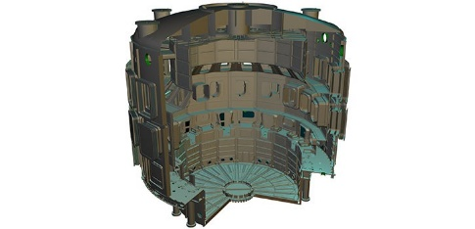Beyond the inner wall of the containment vessel one of several test blanket modules will be placed. These are designed to slow and absorb neutrons in a reliable and efficient manner, limiting damage to the rest of the structure, and breeding tritium for fuel from lithium and the incoming neutrons. Energy absorbed from the fast neutrons is extracted and passed into the primary coolant. This heat energy would then be used to power an electricity-generating turbine in a real power plant; in ITER this generating system is not of scientific interest, so instead the heat will be extracted and disposed of.

## Technical design

1. Cryostat[5]

The cryostat is a large, stainless steel structure surrounding the vacuum vessel and superconducting magnets, providing a super-cool, vacuum environment. It is made up of a single wall cylindrical construction, reinforced by horizontal and vertical ribs. The cryostat is 29.3 meters tall and 28.6 meters wide.

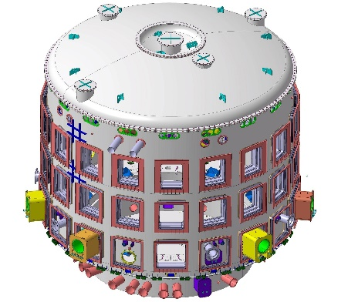The cryostat has many openings, some as large as four meters in diameter, which provide access to the vacuum vessel for cooling systems, magnet feeders, auxiliary heating, diagnostics, and the removal of blanket and divertor parts. Large bellows are used between the cryostat and the vacuum vessel to allow for thermal contraction and expansion in the structures. The cryostat is completely surrounded by a concrete layer known as the bioshield. Above the cryostat, the bioshield is two meters thick.

1. Magnets[6]

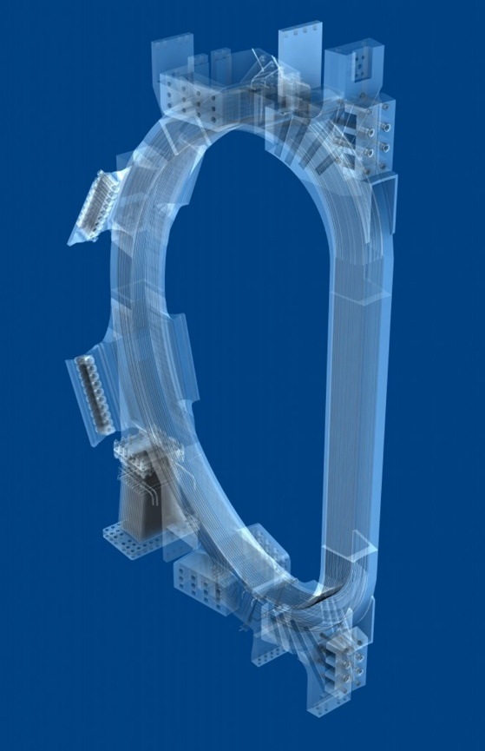The ITER magnet system comprises 18 superconducting toroidal field and 6 poloidal field coils, a central solenoid, and a set of correction coils that magnetically confine, shape and control the plasma inside the vacuum vessel. Additional coils will be implemented to mitigate Edge Localized Modes (ELMs), which are highly energetic outbursts near the plasma edge.

The 48 elements of the ITER magnet system will generate a magnetic field some 200,000 times higher than that of our Earth.

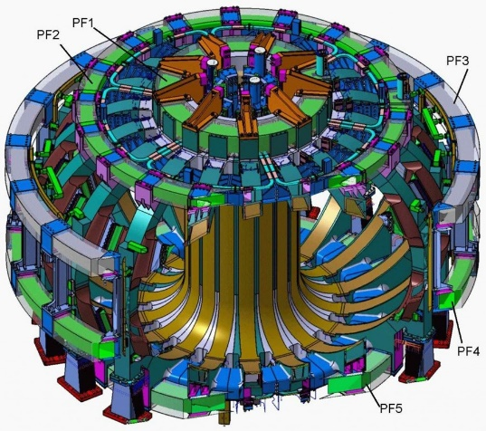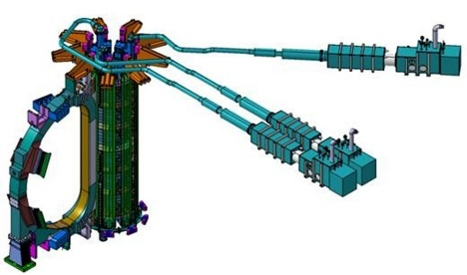For maximum efficiency and to limit energy consumption, ITER uses superconducting magnets that lose their resistance when cooled down to very low temperatures. The toroidal and poloidal field coils lie between the vacuum vessel and the cryostat, where they are cooled and shielded from the heat generating neutrons of the fusion reaction.

The central solenoid—the backbone of the magnet system—is essentially a large transformer.

One of the 18 toroidal field coils.

The poloidal field coil system consists of six independent coils placed outside the toroidal magnet structure.

1. Heating[7]

The temperatures inside the ITER Tokamak must reach 150 million° Celsius—or ten times the temperature at the core of the Sun—in order for the gas in the vacuum chamber to reach the plasma state and for the fusion reaction to occur. The hot plasma must then be sustained at these extreme temperatures in a controlled way in order to extract energy.

The ITER Tokamak will rely on three sources of external heating that work in concert to provide the input heating power of 50 MW required to bring the plasma to the temperature necessary for fusion. These are neutral beam injection and two sources of high-frequency electromagnetic waves.

Ultimately, researchers hope to achieve a "burning plasma"—one in which the energy of the helium nuclei produced by the fusion reaction is enough to maintain the temperature of the plasma. The external heating can then be strongly reduced or switched off altogether. A burning plasma in which at least 50 percent of the energy needed to drive the fusion reaction is generated internally is an essential step to reaching the goal of fusion power generation.

Using injection to heat the fuel in the ITER Tokamak is very much like using steam in the household cappuccino machine to heat milk. Neutral beam injectors are used to shoot uncharged high-energy particles into the plasma where, by way of collision, they transfer their energy to the plasma particles.

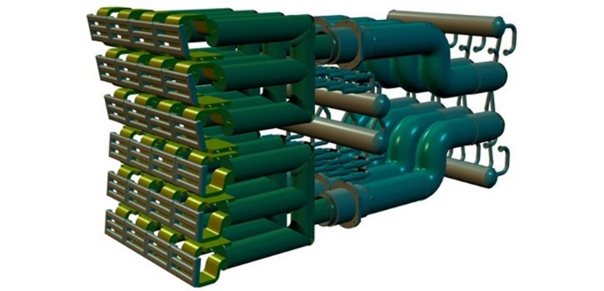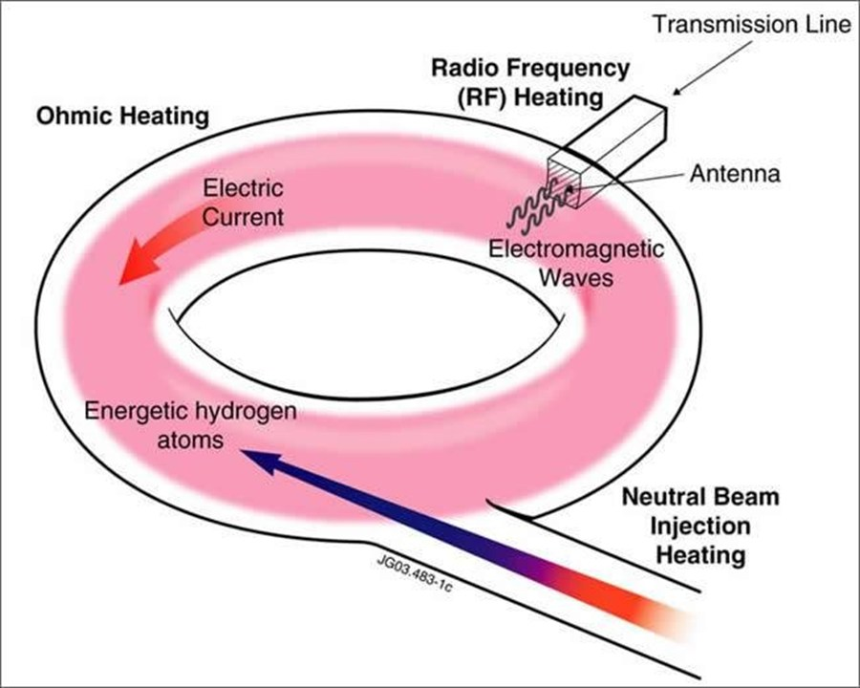Ion and electron cyclotron heating methods use radio waves at different frequencies to bring additional heat to the plasma, much in the same way that a microwave oven transfers heat to food through microwaves.

Transmission lines and Antenna

1. Vacuum Vessel[8]

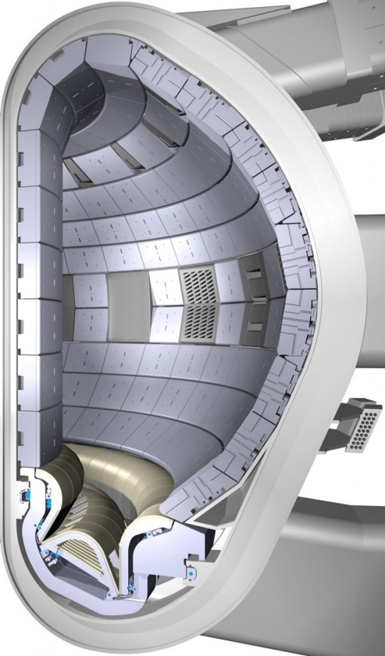The vacuum vessel is a hermetically-sealed steel container inside the cryostat that houses the fusion reaction and acts as a first safety containment barrier. In its doughnut-shaped chamber, or torus, the plasma particles spiral around continuously without touching the walls.

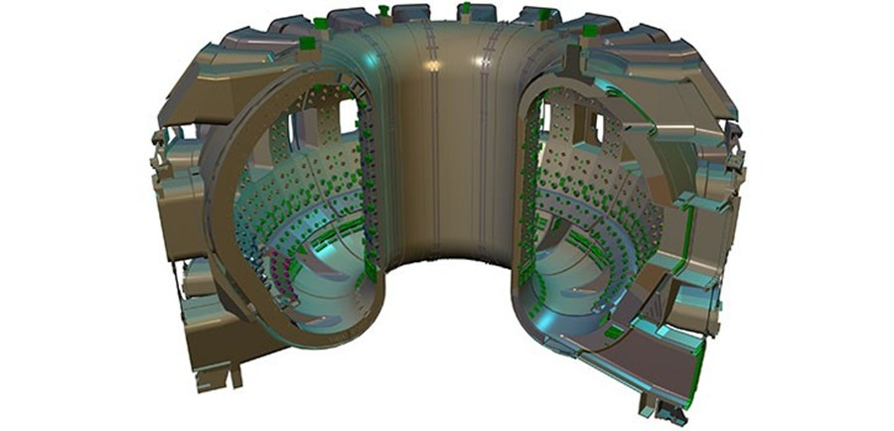The ITER vacuum vessel will be twice as large and sixteen times as heavy as any previous tokamak, with an internal diameter of 6 meters. It will measure a little over 19 meters across by 11 meters high, and weigh in excess of 5,000 tons.

A cut-away of the ITER vacuum vessel showing the blanket modules attached to its inner wall and the divertor at the bottom.

The large stainless steel vacuum vessel provides an enclosed, vacuum environment for the fusion reaction.

1. Blanket[9]

The blanket covers the interior surfaces of the vacuum vessel, providing shielding to the vessel and the superconducting magnets from the heat and neutron fluxes of the fusion reaction. The neutrons are slowed down in the blanket where their kinetic energy is transformed into heat energy and collected by the coolants. In a fusion power plant, this energy will be used for electrical power production.

The ITER blanket is one of the most critical and technically challenging components in ITER: together with the divertor it directly faces the hot plasma. Because of its unique physical properties, beryllium has been chosen as the element to cover the first wall. The rest of the blanket shield will be made of high-strength copper and stainless steel.

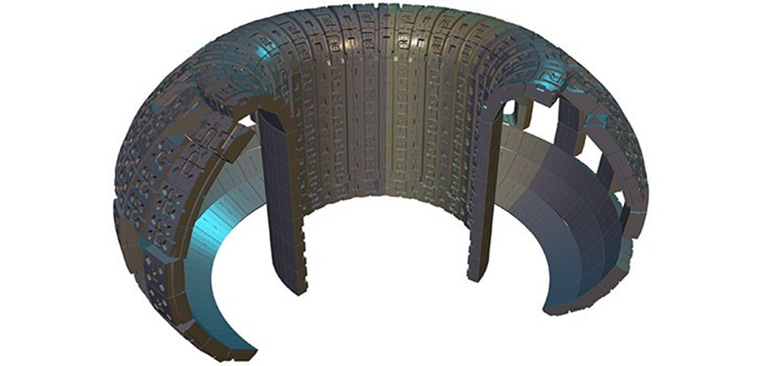At a later stage of the ITER project, test breeding modules will be used to test materials for tritium breeding concepts. A future fusion power plant producing large amounts of power will be required to breed all of its own tritium. ITER will test this essential concept of tritium self-sustainment.

Blanket

1. 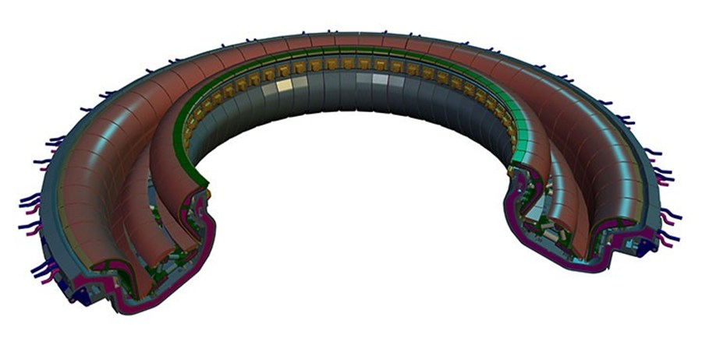Divertor[10]

Divertor

The divertor is one of the key components of the ITER machine. Situated along the bottom of the vacuum vessel, its function is to extract heat and helium ash — both products of the fusion reaction — and other impurities from the plasma, in effect acting like a giant exhaust system. It will comprise two main parts: a supporting structure made primarily from stainless steel, and the plasma-facing components, weighing about 700 tons. The plasma-facing components will be made of tungsten, a high-refractory material.

1. Diagnostics[11]

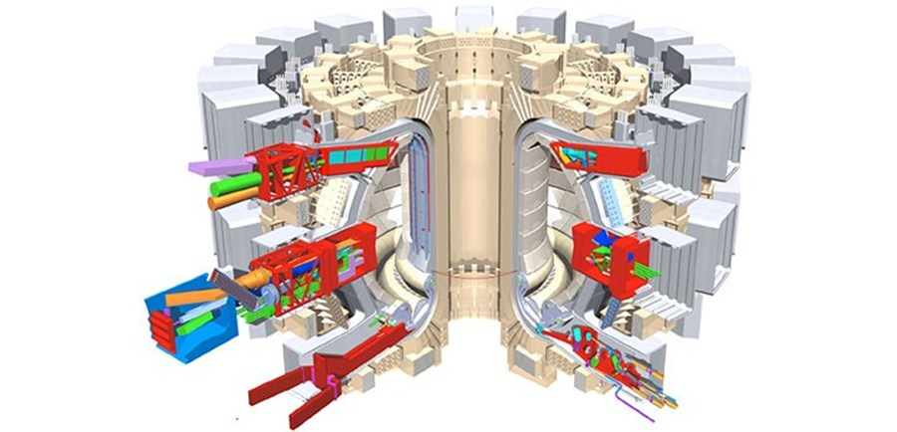An extensive diagnostic system will be installed on the ITER machine to provide the measurements necessary to control, evaluate and optimize plasma performance in ITER and to further the understanding of plasma physics. These include measurements of temperature, density, impurity concentration, and particle and energy confinement times.

Diagnostics systems

The system will comprise about 50 individual measuring systems drawn from the full range of modern plasma diagnostic techniques, including lasers, X-rays, neutron cameras, impurity monitors, particle spectrometers, radiation bolometers, pressure and gas analysis, and optical fibers.

## criticism

The ITER project confronts numerous technically challenging issues. The French Nobel laureate in physics Pierre-Gilles de Gennes said of nuclear fusion, "We say that we will put the sun into a box. The idea is pretty. The problem is, we don't know how to make the box."

A technical concern is that the 14 MeV neutrons produced by the fusion reactions will damage the materials from which the reactor is built. Research is in progress to determine how and/or if reactor walls can be designed to last long enough to make a commercial power plant economically viable in the presence of the intense neutron bombardment. Another problem is that superconducting magnets are damaged by neutron fluxes. A new special research facility, IFMIF, is planned to investigate this problem.

# Bibliography

Wikipedia: Tokamak-http://en.wikipedia.org/wiki/Tokamak

1. Template: Fusion experiments-http://en.wikipedia.org/wiki/Template:Fusion_experiments
2. ITER & Beyond-http://www.iter.org/proj/iterandbeyond
3. Princeton Plasma Physics Laboratory Tokamak TFTR. <http://ippex.pppl.gov/fusion/fusion4.htm>
4. Main components of the tokamak type magnetic confinement system. <http://www.plasma.inpe.br/LAP_Portal/LAP_Site/Text/Tokamaks.htm>
5. Tokamak: Future of Nuclear Power. <http://new.math.uiuc.edu/math198/MA198-2009/farrell1/>
6. What’s fusion?!- <http://fusor.wordpress.com/2009/12/09/whatisfusion/>
7. Wikipedia: ITER-http://en.wikipedia.org/wiki/ITER
8. ITER & Beyond-http://www.iter.org/proj/iterandbeyond
9. ITER: the world's largest Tokamak-http://www.iter.org/mach
10. ITER-the Machine-Cryostat-http://www.iter.org/mach/Cryostat
11. ITER-the Machine-Magnets- <http://www.iter.org/mach/Magnets>
12. ITER-the Machine-Heating- <http://www.iter.org/mach/Heating>
13. ITER-the Machine-Vacuum Vessel- http://www.iter.org/mach/vacuumvessel
14. ITER-the Machine-Blanket-http://www.iter.org/mach/Blanket
15. ITER-the Machine-Divertor- <http://www.iter.org/mach/Divertor>
16. ITER-the Machine-Diagnostics-http://www.iter.org/mach/Diagnostics

1. Wikipedia: Tokamak-http://en.wikipedia.org/wiki/Tokamak
2. Template: Fusion experiments-http://en.wikipedia.org/wiki/Template:Fusion_experiments
3. Wikipedia: ITER-http://en.wikipedia.org/wiki/ITER
4. ITER & Beyond-http://www.iter.org/proj/iterandbeyond
5. ITER-the Machine-Cryostat-http://www.iter.org/mach/Cryostat
6. ITER-the Machine-Magnets- http://www.iter.org/mach/Magnets
7. ITER-the Machine-Heating- http://www.iter.org/mach/Heating
8. ITER-the Machine-Vacuum Vessel- http://www.iter.org/mach/vacuumvessel
9. ITER-the Machine-Blanket-http://www.iter.org/mach/Blanket
10. ITER-the Machine-Divertor- http://www.iter.org/mach/Divertor
11. ITER-the Machine-Diagnostics-http://www.iter.org/mach/Diagnostics